Update of the systematic review of the evidence on psoriasis treatment and diabetes mellitus

We updated the existing "Systematic review of the efficacy, effectiveness and safety of systemic treatments for psoriasis in patients with diabetes mellitus".

Table 1: Living Review History
Version | Search Date | Number of new studies | Additional information added | Implications for conclusions
Update 1 | June 2021 | 1 | See below | See below
Original | September 2019 | 8 | / | /

Eligibility criteria
Apart from the newly included drugs, bimekizumab, certolizumab pegol, risankizumab and tildrakizumab we did not change the search strategy and the inclusion criteria of the previous version. Only briakinumab and cdp571 were no longer searched for.
Table 2: Eligibility criteria for the review update on psoriasis and diabetes mellitus
Patients | Inclusion: adult patients with a clinical diagnosis of psoriasis and a concomitant diabetes mellitus of any type being treated for psoriasis  Exclusion:  patients with psoriatic arthritis only
Intervention | Conventional systemic treatment (aciretin, apremilast, ciclosporin, fumarates, methotrexate) and biologicals (anti TNF alpha: adalimumab, etanercept, certolizumab pegol (new), infliximab; anti-IL12/23: ustekinumab; anti-IL17: bimekizumab (new), brodalumab, ixekizumab, secukinumab; anti-IL23: guselkumab, risankizumab (new), tildarkizumab (new)
Comparator | Comparisons with another included drug and/or placebo
Outcomes | Change in skin lesions based on PASI (Psoriasis Area Severity Index) or PGA (Physician Global Assessment) or another study specific assessment.  Fasting plasma glucose, HbA1c or insulin sensitivity measured by HOMA (Homeostasis Modell Assessment) or other study specific outcomes  Type and proportion of other adverse events  Quality of life based on SF-36 (The Short Form (36) Health Survey), DLQI (Dermatology Life Quality Index) or another study specific assessment.
Study Design | Inclusion:  randomized controlled trials, clinical trials (with and without comparison group), cohort studies, case control studies and cross sectional studies  Exclusion:  case series, case reports, retrospective studies with with less than 100 patients

Information sources
The search strategy was updated and the databases MEDLINE Ovid from 1946 and Embase Ovid from 1974 were searched for the period 2019 to 2 June 2021. Furthermore, we examined the reference lists of included studies to identify references to relevant trails. The full search strategy is shown below. We screened all identified abstracts/titles for eligibility. Included title/abstracts were then screened as full texts based on the above listed eligibility criteria.
Data collection, statistical analysis and evaluation
We performed the screening and did the data extraction using a standardized form. We recorded all full-texts excluded and the primary reason for exclusion (see below).
Methodological quality assessment/ Risk of bias assessment
We assigned Levels of Evidence for all studies included using the Center of Evidence Based Medicine Oxford recommendations. To assess risk of bias in randomized trials we additionally used the RoB 2.0 tool¹.
Results
Our update search yielded 423 citations, one fulfilled the inclusion criteria² (see study selection flow chart).
We did not find any studies on systemic treatment with apremilast, bimekizumab, certolizumab pegol, brodalumab, fumarates, guselkumab, ixekizumab, risankizumab, tildrakizumab that reported diabetes mellitus outcomes neither in the original search nor in the update.
Figure 1: Study selection flowchart for the selection of studies for the review update on psoriasis and diabetes mellitus
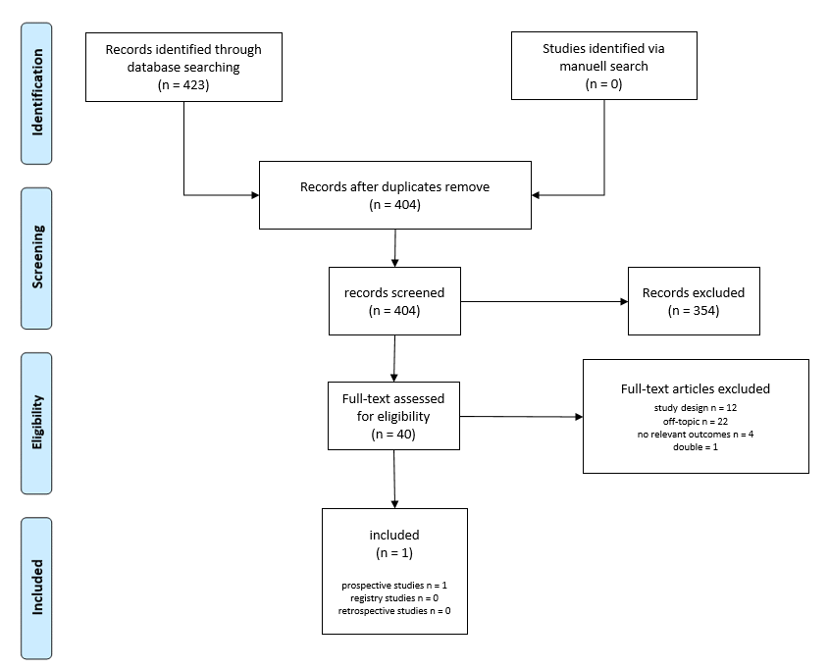
Based on the “Levels of Evidence - Center of Evidence Based Medicine Oxford recommendations” prospective studies²⁻⁶ were categorized level 2 and retrospective studies⁷⁻¹⁰ level 3. Results of the additional assessment for prospective randomized studies with Risk of Bias Tool 2 (RoB 2) are shown in Table 3.
Table 3: Risk of bias in prospective studies.
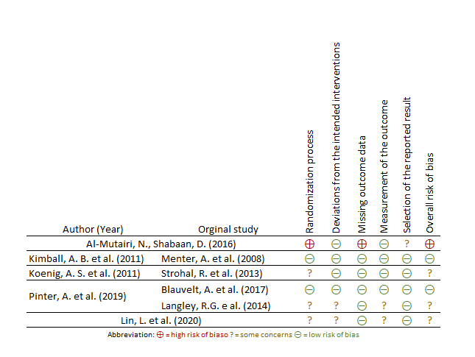
Data for overall 3481 patients with psoriasis and diabetes mellitus was extracted. Summarized results, sorted by study type are shown below in table 4 and 5.

Table 3: Prospective data from the included studies for the systematic review of the evidence on psoriasis treatment and diabetes mellitus
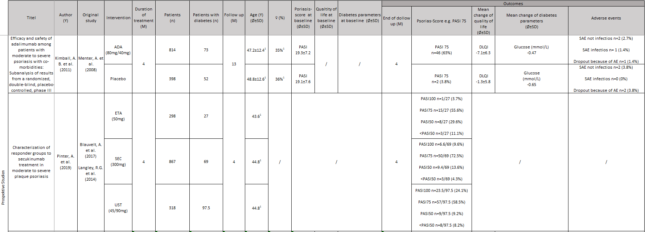

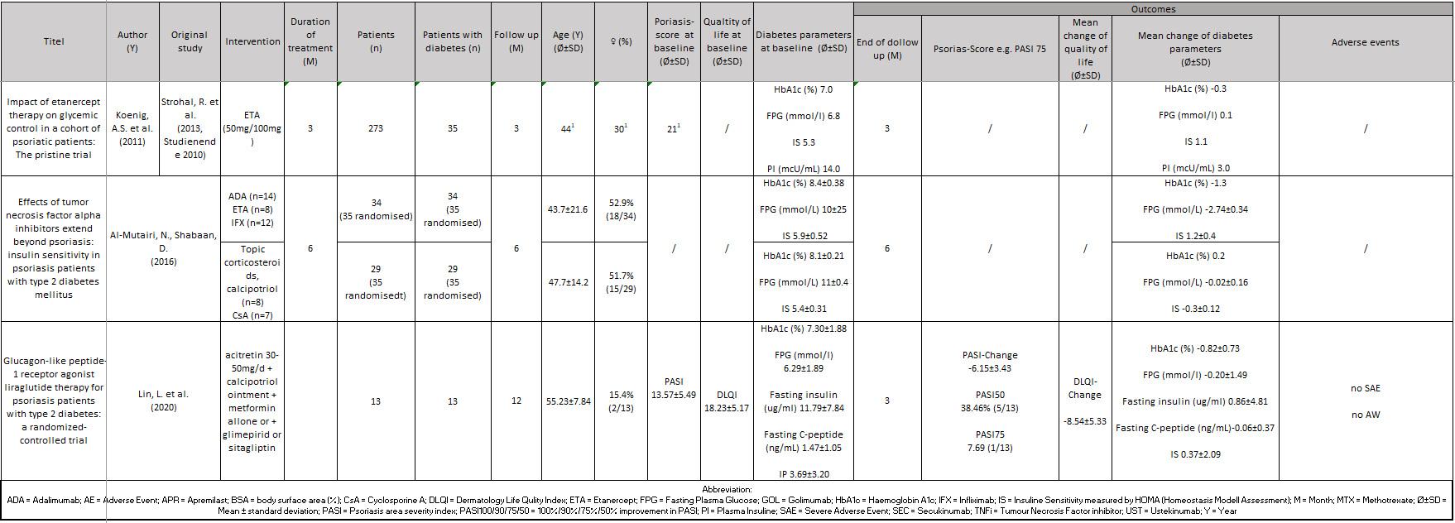

Table 4: Retrospective data from the included studies for the systematic review of the evidence on psoriasis treatment and diabetes mellitus

Table 6: Search strategy for the review update on psoriasis and diabetes mellitus (Embase via Ovid)
1. | exp Psoriasis/ or Psoria*.mp.
2. | pustulosis palmaris et plantaris.ti,ab.
3. | (pustulosis and palm and soles).ti,ab.
4. | palmoplantar* pustulosis.ti,ab.
5. | 1 or 2 or 3 or 4
6. | Urea/ or Urea*.mp.
7. | uric acid.mp. or Uric Acid/
8. | salicyl* acid.mp. or Salicylic Acid/
9. | Calcineu* inhibito*.mp. or Calcineurin Inhibitors/
10. | Tacrolimus/ or Pimecrolim*.mp.
11. | dithranol*.mp. or Anthralin/
12. | Cortisone/ or cortiso*.mp.
13. | Betamethasone/ or Betametha*.mp.
14. | mometaso*.mp. or Glucocorticoids/ or Mometasone Furoate/
15. | Retinoids/ or tazarot*.mp.
16. | coal tar.mp. or Coal Tar/
17. | vit d3.mp or Cholecalciferol/
18. | calcipotrio*.mp.
19. | tacalcito*.mp.
20. | Calcitriol/ or calcitrio*.mp.
21. | phototherap*.mp. or exp Phototherapy/
22. | PUVA Therapy/ or Photochemotherapy/ or PUVA.mp.
23. | exp Ultraviolet Therapy/ or UV-B therap*.mp.
24. | photodynamic therap*.mp.
25. | photochemotherap*.mp.
26. | light therap*.mp.
27. | photoradiation therap*.mp.
28. | BBUVB.mp.
29. | NBUVB.mp.
30. | BB-UVB.mp.
31. | NB-UVB.mp.
32. | broad band uvb.mp.
33. | broad band ultraviolet.mp.
34. | narrow band uvb.mp.
35. | narrow band ultraviolet.mp.
36. | psoralen ultraviolet a.mp.
37. | psoralen uva.mp.
38. | Laser therap*.mp. or Laser Therapy/
39. | Ciclospori*.mp. or Cyclosporine/
40. | cyclospor*.mp.
41. | fumar*.mp. or exp Fumarates/
42. | fumaderm.mp.
43. | dimethylfumara*.mp.
44. | fae.ti,ab.
45. | dmf.ti,ab.
46. | exp Methotrexate/ or MTX.mp.
47. | methotrexa*.mp.
48. | amethopterin.mp.
49. | mexate.mp.
50. | acitretin.mp. or Acitretin/
51. | Retinoids/
52. | Phosphodiesterase 4 Inhibitors/ or apremilast.mp.
53. | (etanercep* or enbrel).mp. or Etanercept/
54. | (Infliximab* or remicade).mp. or Infliximab/
55. | ustekinumab.mp. or Ustekinumab/
56. | CNTO 1275.mp.
57. | stelara.mp.
58. | secukinumab.mp.
59. | guselkumab.mp.
60. | adalimumab*.mp. or Adalimumab/
61. | (d2e7 or humira).mp.
62. | exp Antibodies, Monoclonal/
63. | monoclonal antibod*.mp.
64. | exp Interleukin-23/ or exp Interleukin-12/
65. | brodalumab.mp.
66. | ixekizumab.mp.
67. | bimekizumab.mp.
68. | (tumor necrosis factor-alpha or tumour necrosis factor-alpha).mp.
69. | certolizuma*.mp.
70. | risankizumab.mp.
71. | tildrakizumab.mp.
72. | anti tnf.mp.
73. | (tumor necrosis factor antibod* or tumour necrosis factor antibod*).mp.
74. | (antitumor necrosis factor or antitumour necrosis factor).mp.
75. | (anti tumor necrosis factor or anti tumour necrosis factor).mp.
76. | (tnf antibod* or tnf alpha antibod*).mp.
77. | climate therap*.mp. or Climatotherapy/
78. | Psychotherapy/ or psychosocial therap*.mp.
79. | exp Tumor Necrosis Factor-alpha/
80. | 6 or 7 or 8 or 9 or 10 or 11 or 12 or 13 or 14 or 15 or 16 or 17 or 18 or 19 or 20 or 21 or 22 or 23 or 24 or 25 or 26 or 27 or 28 or 29 or 30 or 31 or 32 or 33 or 34 or 35 or 36 or 37 or 38 or 39 or 40 or 41 or 42 or 43 or 44 or 45 or 46 or 47 or 48 or 49 or 50 or 51 or 52 or 53 or 54 or 55 or 56 or 57 or 58 or 59 or 60 or 61 or 62 or 63 or 64 or 65 or 66 or 67 or 68 or 69 or 70 or 71 or 72 or 73 or 74 or 75 or 76 or 77 or 78 or 78 or 79
81. | 5 and 80
82. | Diabetes mellitus.mp. or Diabetes mellitus/
83. | Diabetes Mellitus, Type 1/ or Diabetes Mellitus, Type 2/ or diabetes mellitus type 1.mp.
84. | DM.ti,ab.
85. | (Type 1 diabetes mellitus or type 2 diabetes mellitus).ti,ab.
86. | (type 1 DM or type 2 DM).ti,ab.
87. | 82 or 83 or 84 or 85 or 86
88. | 81 and 87
Additional time filters:
("2019*" or "2020*" or "2021*").dc. (Embase)
("2019*" or "2020*" or "2021*").dt. (Medline)

Table 7: Excluded full-texts for the review update on psoriasis and diabetes mellitus:
R. Abramczyk | 2020 | study design
M. Aksentijevich | 2020 | study design
J. P. Allam | 2019 | off-topic
A.G. Ashbaugh | 2020 | study design
F. Assan | 2021 | off-topic
M. Augustin | 2020 | off-topic
I. Belinchon-Romero | 2021 | off-topic
F. Bellinato | 2019 | off-topic
F. Benhadou | 2020 | off-topic
K. P. Botelho | 2020 | no relevant outcomes
F. Diotallevi | 2020 | off-topic
C. V. Fricke | 2019 | study design
J. M. Gelfand | 2020 | off-topic
S. Gerdes | 2020 | no relevant outcomes
N. Goolam Mahyoodeen | 2019 | off-topic
- B. Gottlieb | 2021 | off-topic
R. Greenberg | 2021 | off-topic
- Grodner | 2021 | off-topic
M. Hajiebrahimi | 2020 | off-topic
N. Joseph | 2020 | off-topic
K. Kamiya | 2021 | off-topic
E. Kapniari | 2020 | no relevant outcomes
E. Kapniari | 2020 | study design
E. H. Klujszo | 2020 | study design
J. L. W. Lambert | 2020 | study design
M. G. Lebwohl | 2021 | off-topic
M. G. Lebwohl | 2021 | study design
L. Legiawati | 2020 | off-topic
M. Lynch | 2021 | study design
M. Lynch | 2021 | double
M. Lynch | 2021 | off topic
S. Mazzilli | 2020 | no relevant outcomes
J. Nowowiejska | 2020 | study design
S. Pannu | 2021 | study design
L. Rodriguez Fernandez-Freire | 2020 | off-topic
R. Ruiz-Villaverde | 2021 | off topic
- W. Schwarz | 2020 | off topic
M. Teklu | 2021 | off topic
- von Stebut | 2020 | study design

References
1. Sterne JAC, Savović J, Page MJ, et al. RoB 2: a revised tool for assessing risk of bias in randomised trials. Bmj. Aug 28 2019;366:l4898. doi:10.1136/bmj.l4898
2. Lin L, Xu X, Yu Y, et al. Glucagon-like peptide-1 receptor agonist liraglutide therapy for psoriasis patients with type 2 diabetes: a randomized-controlled trial. J Dermatolog Treat. Sep 24 2020:1-7. doi:10.1080/09546634.2020.1826392
3. Koenig AS, Szumski A, Pedersen R, Robertson D. Impact of Etanercept Therapy on Glycemical Control in a Cohort of Psoriatic Patients: The PRISTINE Trial. 2010;
4. Al-Mutairi N, Shabaan D. Effects of tumor necrosis factor α inhibitors extend beyond psoriasis: insulin sensitivity in psoriasis patients with type 2 diabetes mellitus. Cutis. Mar 2016;97(3):235-41.
5. Kimball AB, Bensimon AG, Guerin A, et al. Efficacy and safety of adalimumab among patients with moderate to severe psoriasis with co-morbidities: Subanalysis of results from a randomized, double-blind, placebo-controlled, phase III trial. Am J Clin Dermatol. Feb 1 2011;12(1):51-62. doi:10.2165/11530640-000000000-00000
6. Pinter A, Gerdes S, Papavassilis C, Reinhardt M. Characterization of responder groups to secukinumab treatment in moderate to severe plaque psoriasis. J Dermatolog Treat. Dec 2020;31(8):769-775. doi:10.1080/09546634.2019.1626973
7. Kalb RE, Fiorentino DF, Lebwohl MG, et al. Risk of Serious Infection With Biologic and Systemic Treatment of Psoriasis: Results From the Psoriasis Longitudinal Assessment and Registry (PSOLAR). JAMA Dermatol. Sep 2015;151(9):961-9. doi:10.1001/jamadermatol.2015.0718
8. Hong JR, Lee YW, Choe YB, Ahn KJ. Risk factors for increased serum creatinine level in patients with psoriasis treated with cyclosporine in a real-world practice. Dermatol Ther. May 2019;32(3):e12875. doi:10.1111/dth.12875
9. Wu JJ, Rowan CG, Bebchuk JD, Anthony MS. No association between TNF inhibitor and methotrexate therapy versus methotrexate in changes in hemoglobin A1C and fasting glucose among psoriasis, psoriatic arthritis, and rheumatoid arthritis patients. J Drugs Dermatol. Feb 2015;14(2):159-66.
10. Wu JJ, Liu L, Asgari MM, et al. Initiation of TNF inhibitor therapy and change in physiologic measures in psoriasis. J Eur Acad Dermatol Venereol. Oct 2014;28(10):1380-7. doi:10.1111/jdv.12296

